Phase 3 – Intrusion Detection Method

Installing Suricata using the fwg cmds: –
  - sudo apt update CC sudo apt install suricata -y
  - suricata -v
  - sudo systemctl start suricata
  - Sudo systemctl enable suricata

Custom Rules File (/etc/suricata/rules/local.rules)- these rules look for specific patterns in the packet headers and payloads.

  - Rule 1: ICMP Recon (Alert on Ping)
alert icmp any any -> any any (msg:"ICMP Ping Detected"; sid:1000001; rev:1;)

  - Rule 2: Nmap SYN Scan Detection
alert tcp any any -> any any (msg:"Nmap SYN Scan Detected"; flags:S; ack:0; sid:1000002; rev:1;)

  - Rule 3: Telnet Usage
alert tcp any any -> any 23 (msg:"Telnet Traffic Detected"; sid:1000003; rev:1;)

  - Rule 4: FTP Credential Exposure
alert tcp any any -> any 21 (msg:"FTP USER/PASS in Cleartext"; content:"USER"; nocase; sid:1000004; rev:1;)
alert tcp any any -> any 21 (msg:"FTP USER/PASS in Cleartext"; content:"PASS"; nocase; sid:1000005; rev:1;)

  - Rule 5: Multiple Port Hits (Thresholding)
alert tcp any any -> any any (msg:"Potential Port Scan - Multiple Ports"; flow:to_server; flags:S; threshold:type both, track by_src, count 5, seconds 10; sid:1000006; rev:1;)
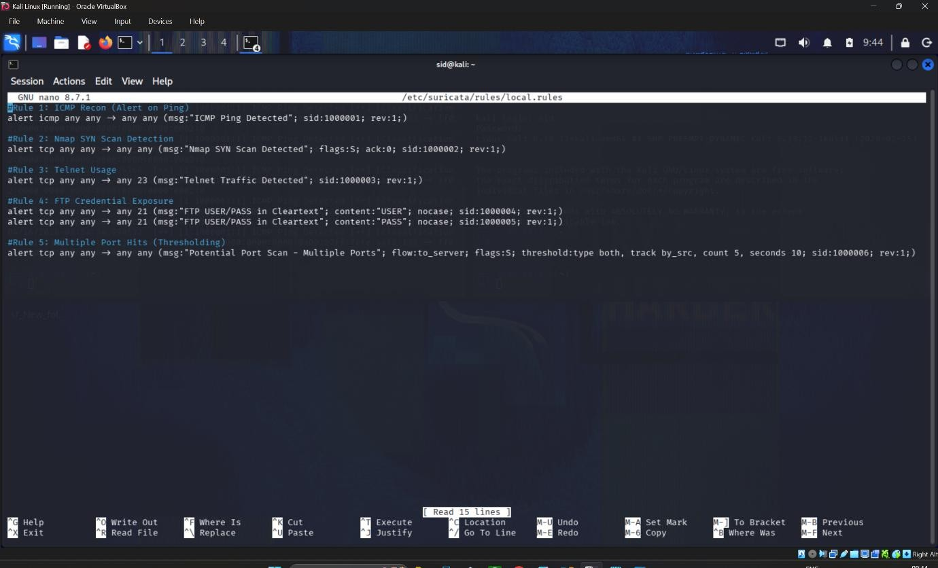

Commands Used for Testing

  - The Attacker, execute the following to trigger the rules:

Task | Command | Target IP
Ping Test | ping 10.0.2.3 | Kali IP
Nmap Scan | nmap -ss 10.0.2.3 | Kali IP
Telnet | telnet 10.0.2.3 | Kali IP
FTP Login | ftp 10.0.2.3 | Kali IP

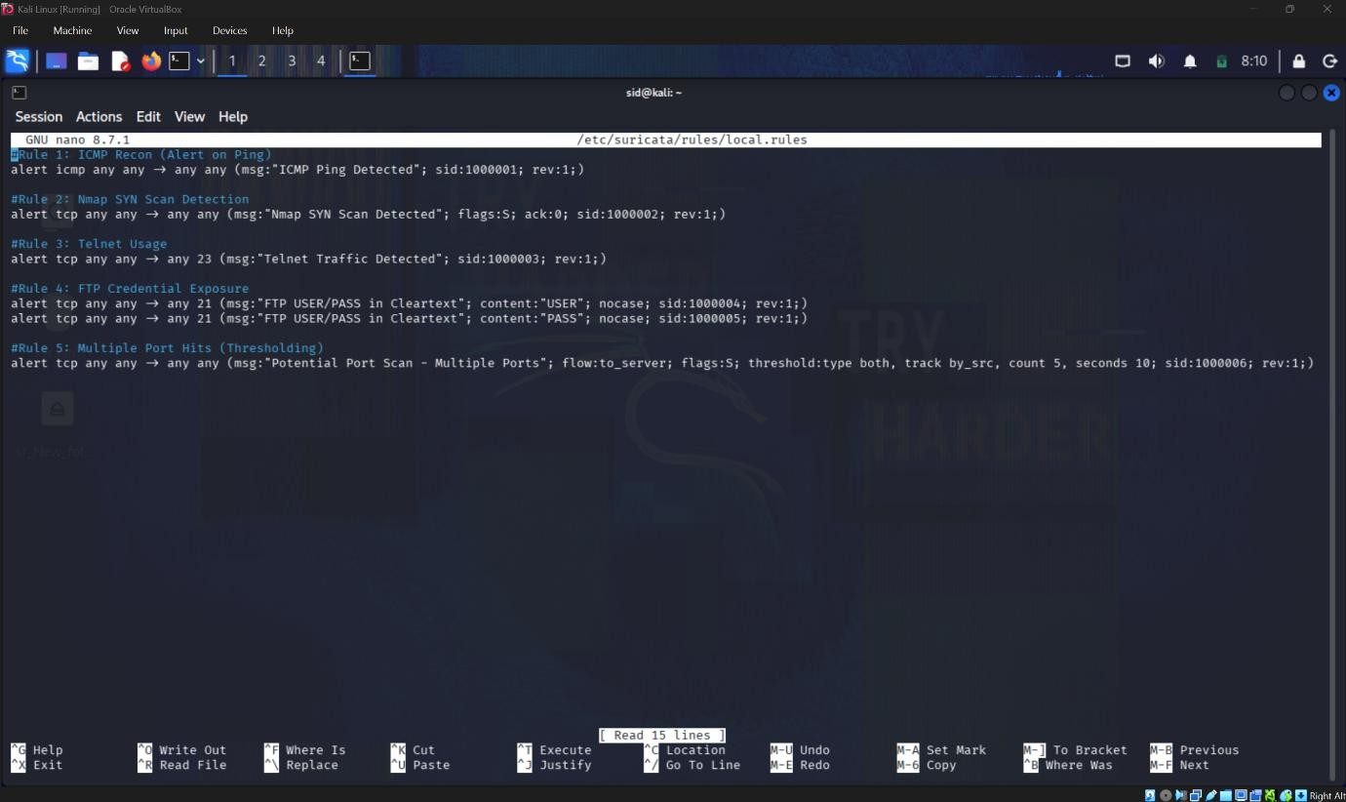

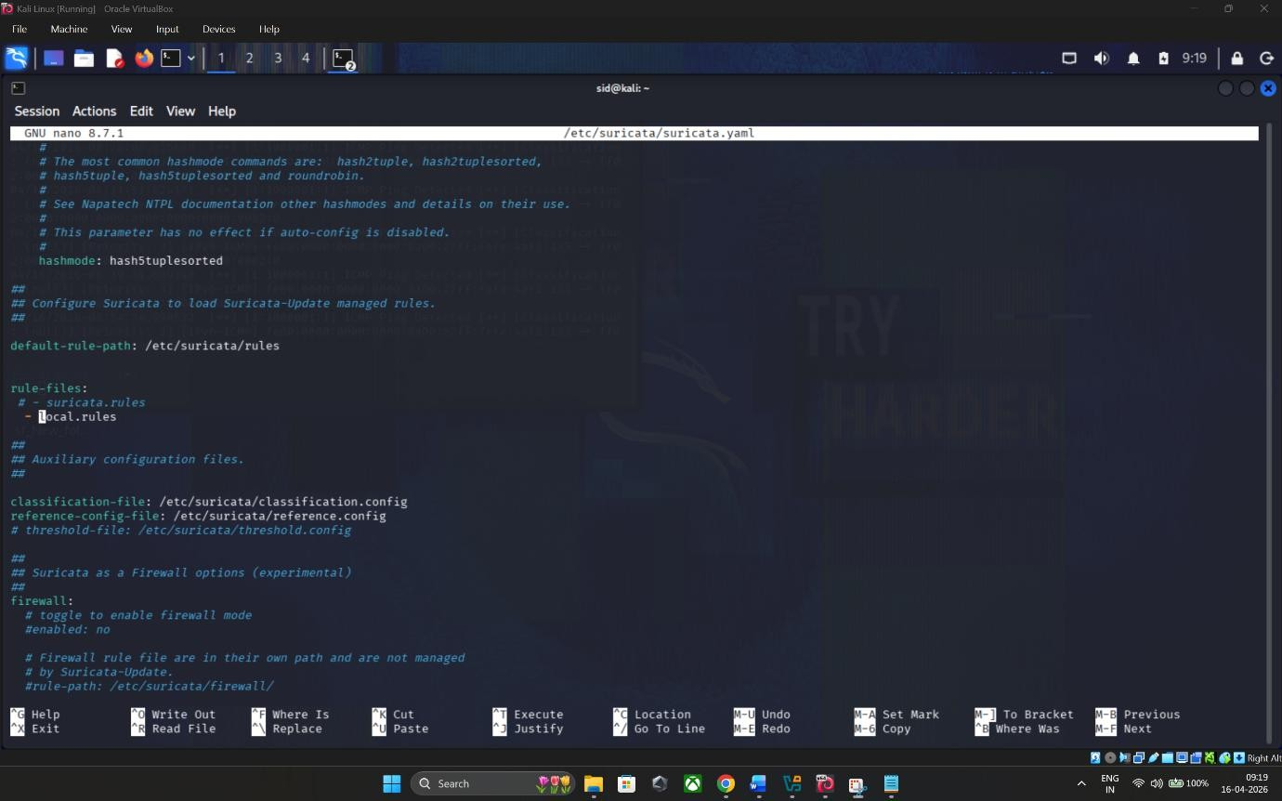
  - Enabling custom rules to Suricata Config

Which rule takes priotiry?

FTP Credential Exposure is the highest priority.

Priority | Rule | Description | Reason
1 (High) | Rule 4 | FTP  Credentials | Critical: Actual loss of credentials. Direct path to system compromise.
2 (Med) | Rule 3 | Telnet Usage | Warning: Use of an insecure protocol that will  lead to credential theft if used.
3 (Low) | Rule 2  s 5 | Nmap/Port Scans | Informational: Active probing. Hostile intent is clear, but no breach has occurred.
4  (Lowest) | Rule 1 | ICMP Ping | Noise: Ping is often used for legitimate network troubleshooting.

